**LAB 08**

**SUBMISSION INSTRUCTIONS**

Submit 1 file.

* Lab 08.pdf

**QUESTION**

Solutions must be typed (or images pasted) below the respective questions. When done, save the lab as a pdf file with the right file name. For searching questions, show how you get the final answer (show the indexes just like in the notes). For sorting questions, show the different passes (just like in the example slides).

1. What is the best and the 2 worst-case scenarios of using a linear search?

The best-case scenario is the that the key is on the first index. The worst case is that it is the last in the index or it is not in the list at all.

1. Using a tracing table, show how 6 would be obtained using a binary search.

**2 4 5 6 8 11 15**

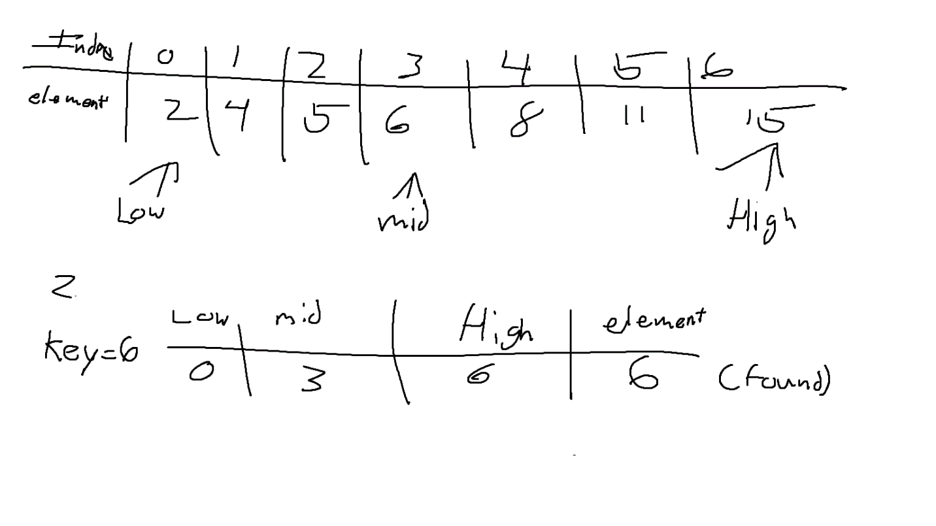

1. Using a tracing table, show how 2 would be obtained using a binary search.

**2 4 5 6 8 11 15**

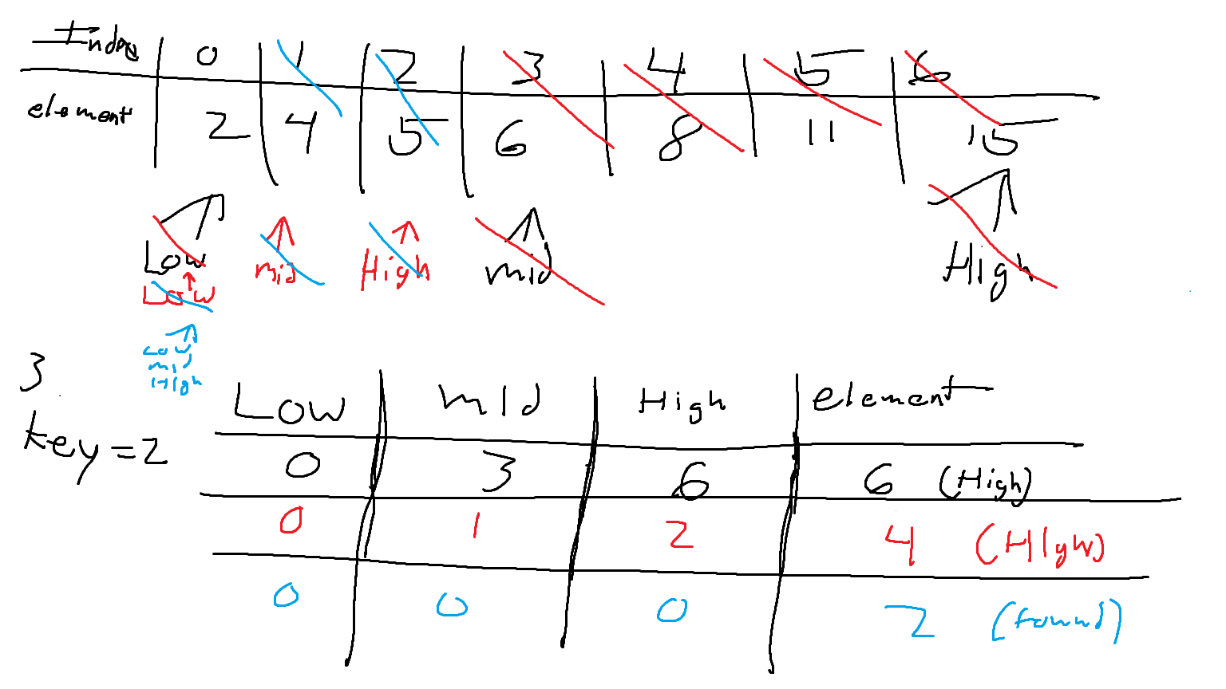

1. Using a tracing table, show how 15 would be obtained using a binary search.

**2 4 5 6 8 11 15**

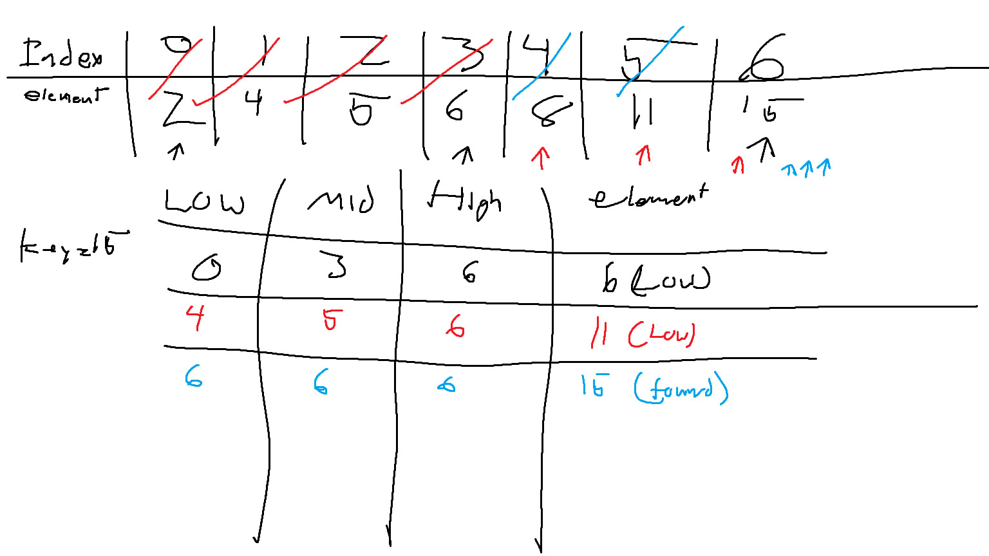

1. Sort the collection below in ascending order using the bubble sort.

**2 9 5 4 8 1**

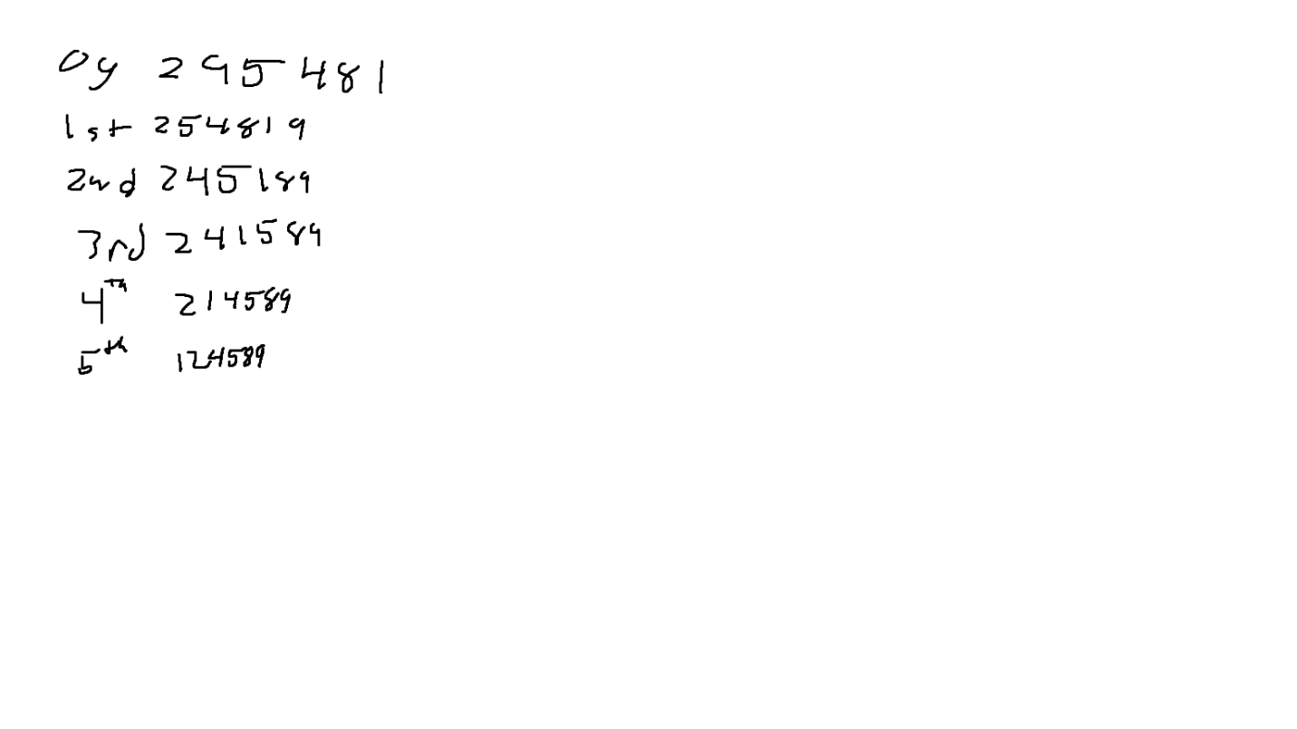

1. Sort the collection below in descending order using the bubble sort.

**2 9 5 4 8 1**

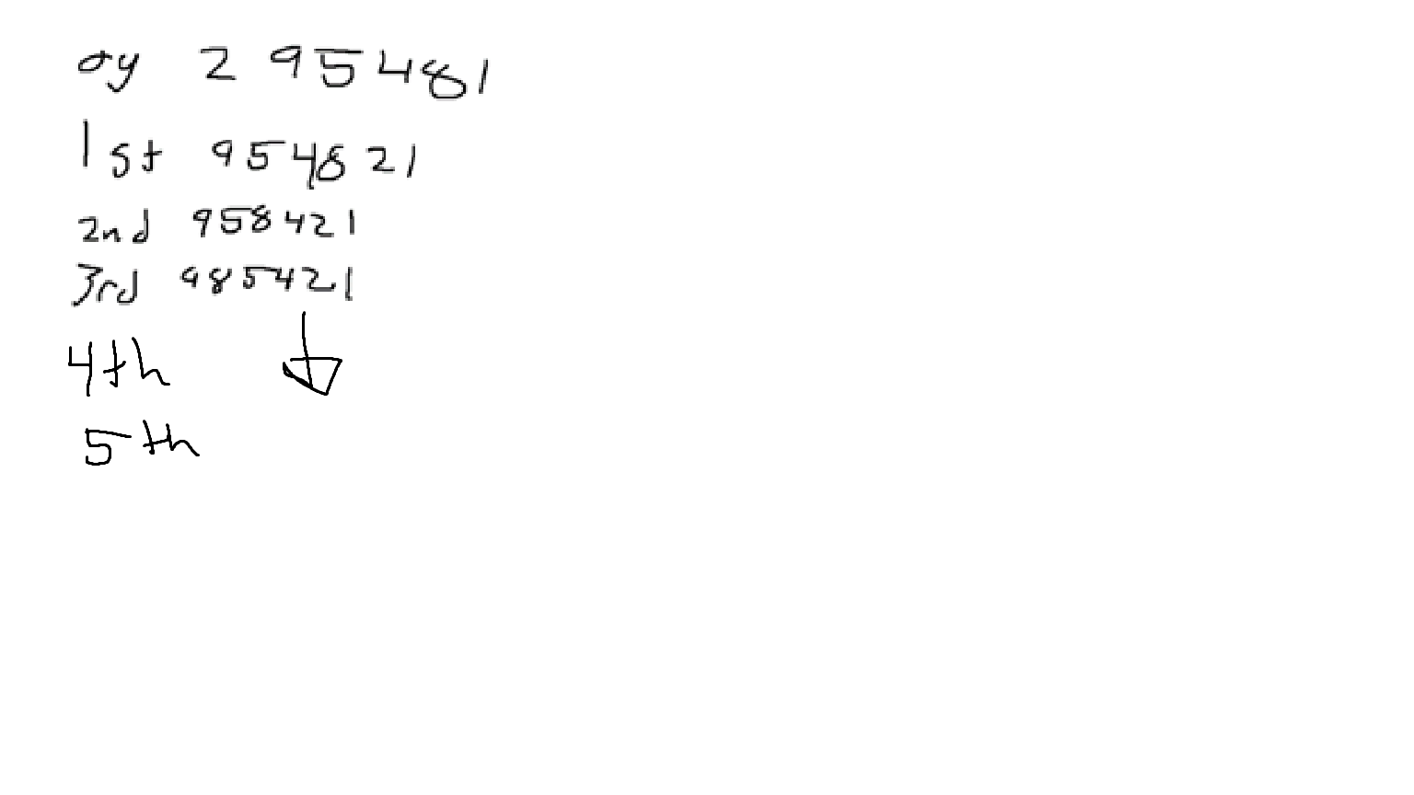

1. Sort the collection below in ascending order using the selection sort.

**2 9 5 4 8 1**

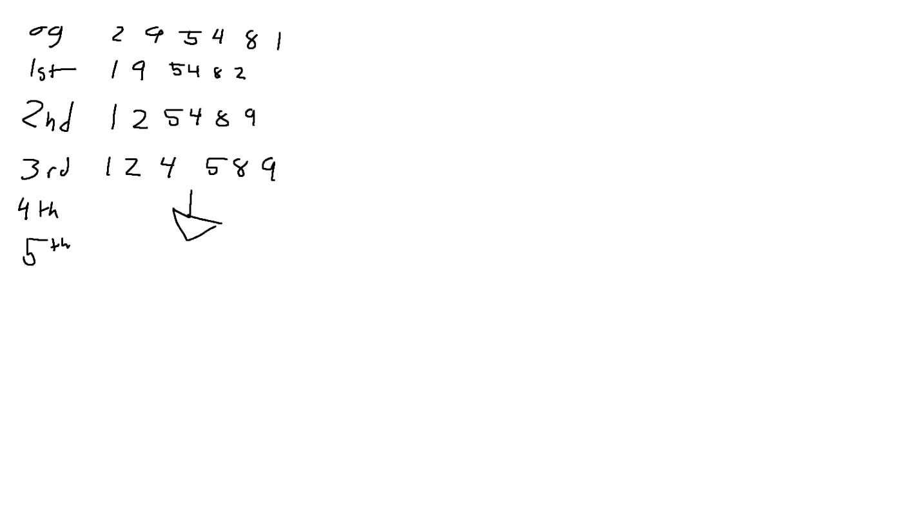

1. Sort the collection below in descending order using the selection sort.

**2 9 5 4 8 1**

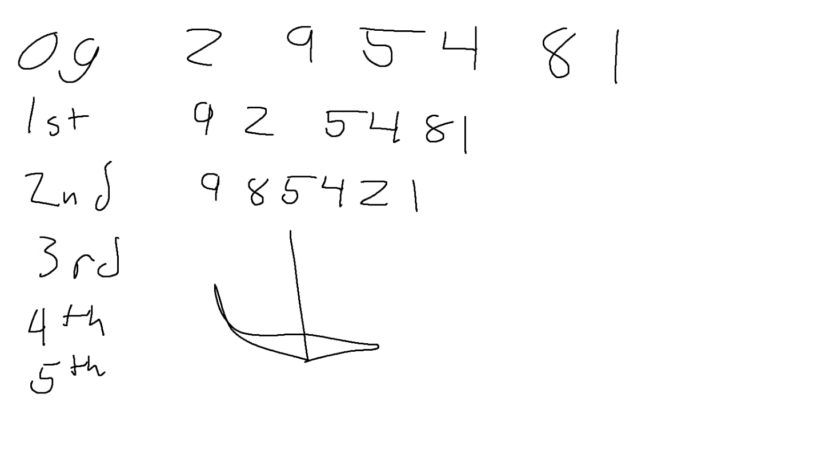

1. Sort the collection below in ascending order using the insertion sort.

**2 9 5 4 8 1**

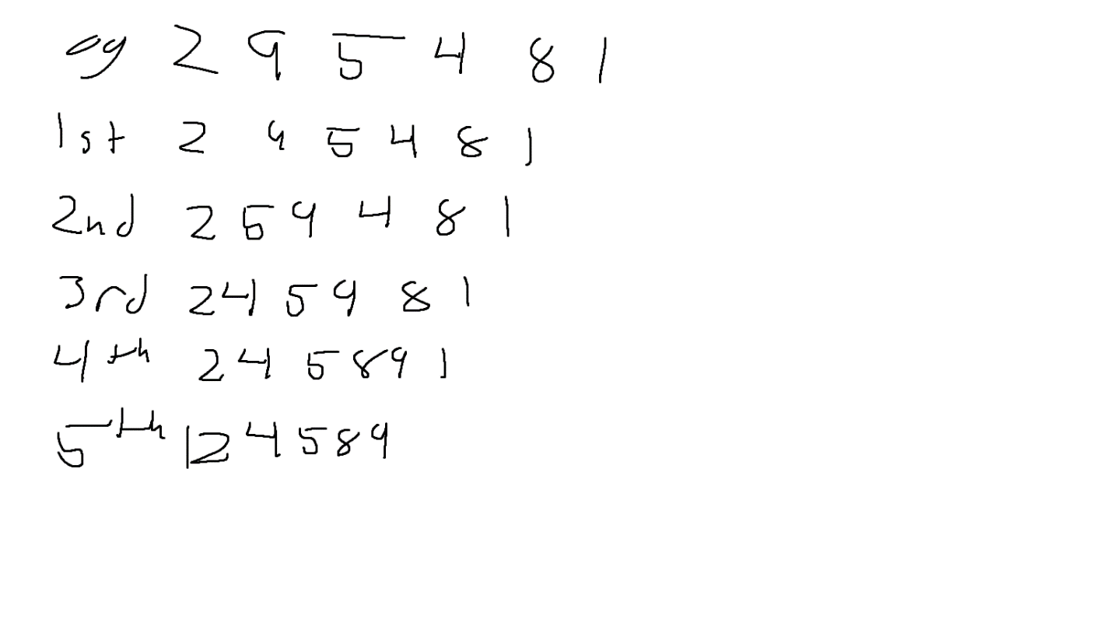

1. Sort the collection below in descending order using the insertion sort.

**2 9 5 4 8 1**

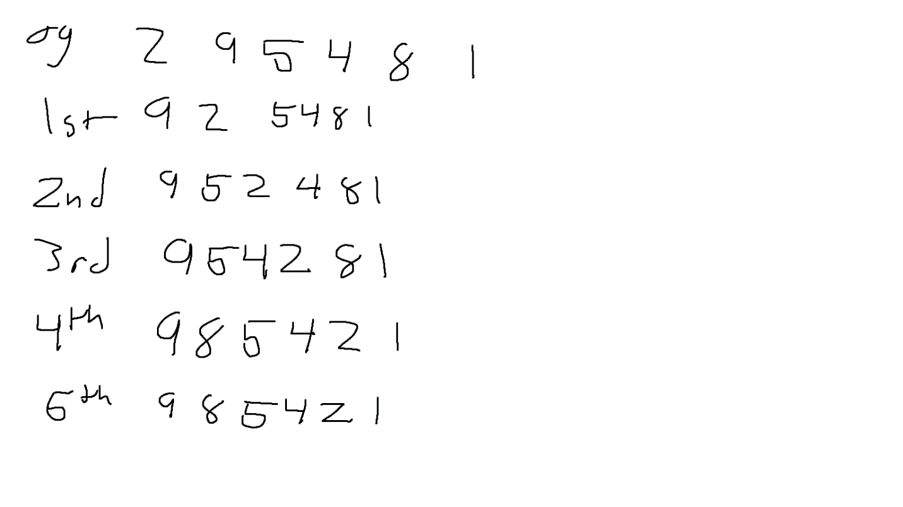

1. Sort the collection below in ascending order using the merge sort.

**2 9 5 4 8 1**

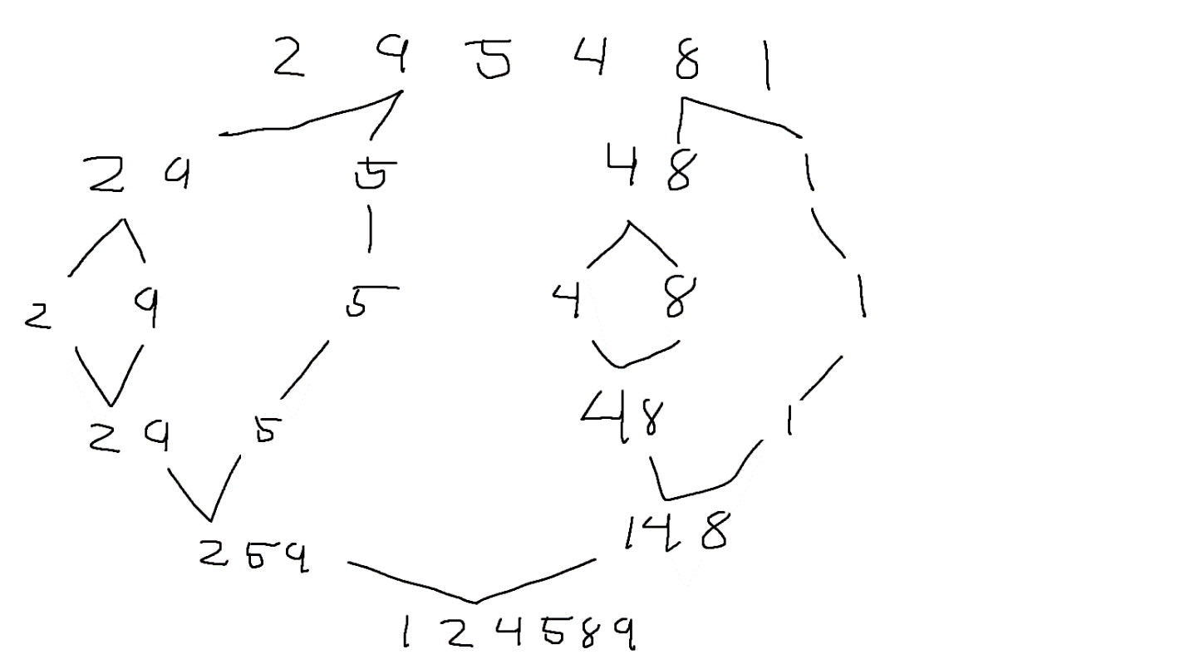

1. Sort the collection below in descending order using the merge sort.

**2 9 5 4 8 1**

